**FORMLABS SOP V1.1**

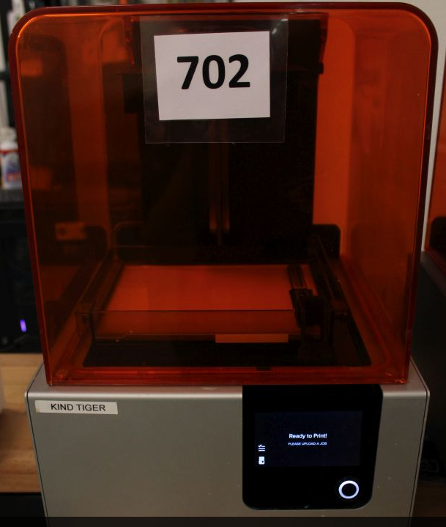

This SOP will guide you through the process of 3D printing on Formlabs printers ONLY. If you are not sure of anything having to do with this printer, STOP AND SEEK CLARIFICATION. Please follow all safety and PPE (personal protective equipment) recommendations.

You are expected to clean up after each and every use. You are expected to help maintain the station if you ever use it.

**Tools you’ll need:**

1. Safety glasses
2. Latex or nitrile gloves
3. Preform nesting software
4. Formlabs Form2 printer
5. Silicone spatula
6. Paper towels
7. 91% Isopropyl alcohol
8. Strainer
9. 16 oz plastic cups
10. Putty knife / removal tool
11. Shop rags
12. Formlabs cure box
13. Alcohol bath setup
14. Timer

See photos for reference.

**Layout**

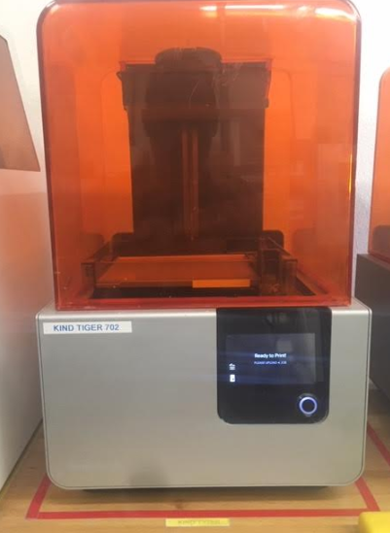 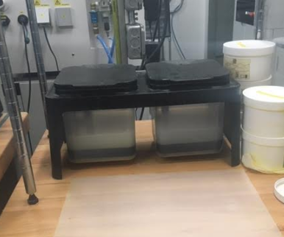

POST PROCESSING STATION

ALCOHOL BATHS

FORMLABS - KIND TIGER

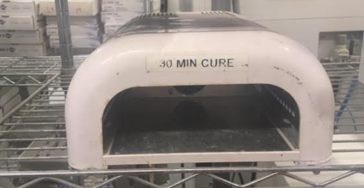 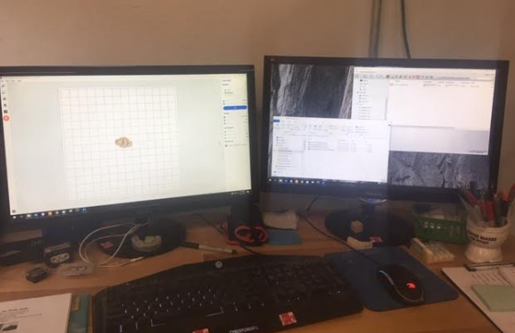

3D PRINTER WORKSTATION

FORMLABS – LIGHT CURE

**Gloves and safety glasses should be worn throughout the process both for contamination prevention and safety.**

**What NOT to do:**

**Do NOT** put any other material in the alcohol baths or risk unintended chemical reactions.

(See SDS located online for isopropyl bath)

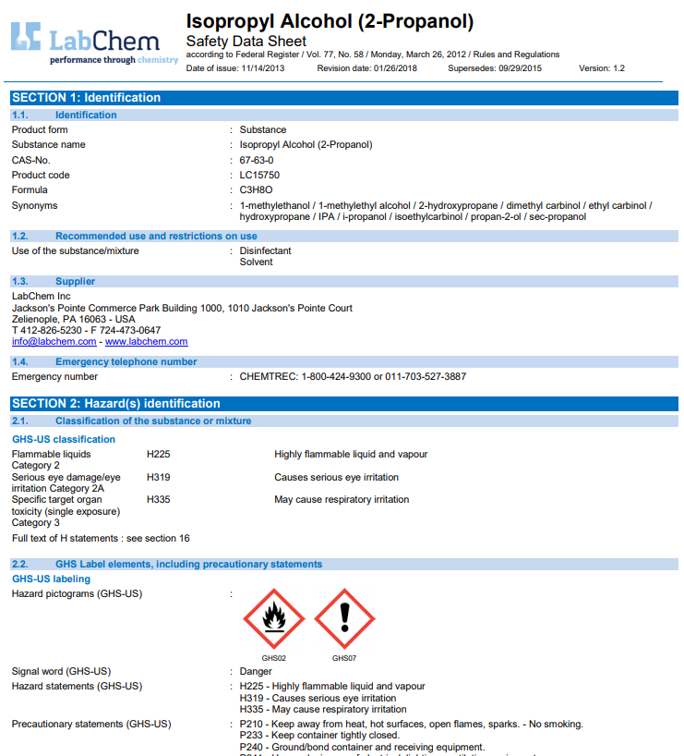

**Do NOT** expose the alcohol solution to sparks or heat.

**Do NOT** forget models in alcohol baths.

**Solutions list**

**Formlabs resin** – purchased and premixed

Lifespan – until it no longer allows for accurate creations of models

Replacement – when empty and must replace tray after fourth bottle

Disposal – Dispose of contents / container in accordance with local / regional / national / international regulations.

**Isopropyl alcohol** – purchased premixed

Lifespan – 3 years from mfg date

Replacement – when discolored / dirty

Disposal – Dispose of contents / container in accordance with local / regional / national / international regulations.

**Best practices**

Always F7 models prior to printing to be sure you get the latest design.

Always check all dies for supports on margins.

Always set a timer for alcohol baths.

Always let models sit for a few minutes to air dry prior to cure.

Always be sure the models are clean prior to curing.

Always save your print job to local disk drive with proper naming convention.

Be sure all tools and station are clean prior to use. Change resin and alcohol solution if necessary.

Follow due date priority when deciding what to print first.

Step 1. Find and F7 models in Dental manager.

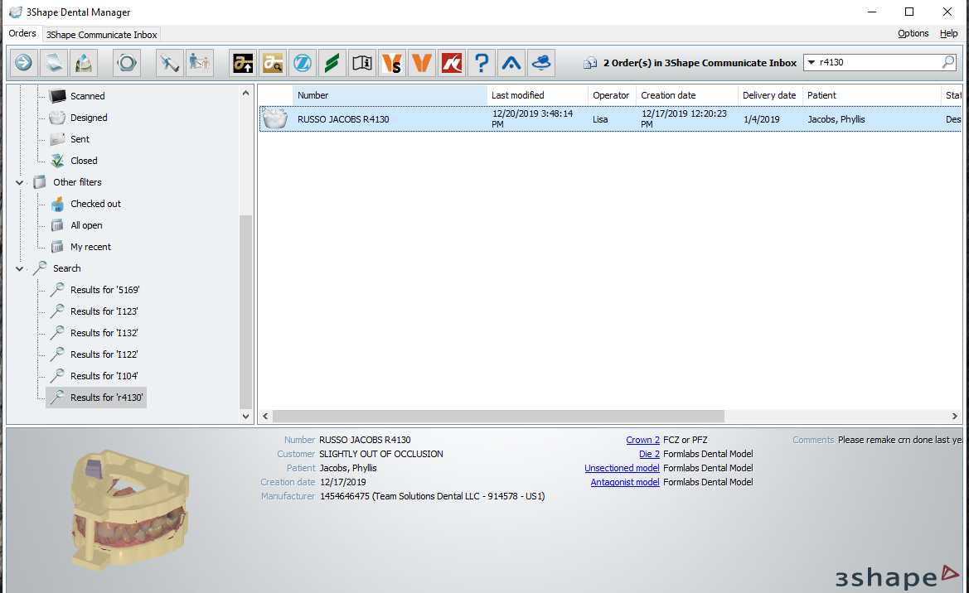

Step 2. Open file explorer to model location, find models, and open folder to find items to be printed (****Full arches and quads will require that everything be printed. Solids only require unsectioned [sic] model and all dies.****)

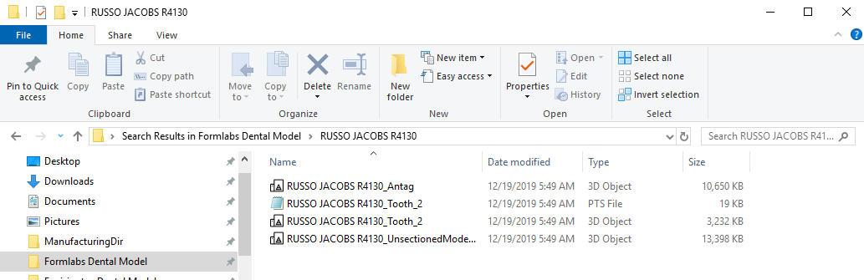

Step 3. Open preform nesting software by clicking icon . Choose the printer to gain access to virtual build plate. Drag and drop model items onto virtual build plate.

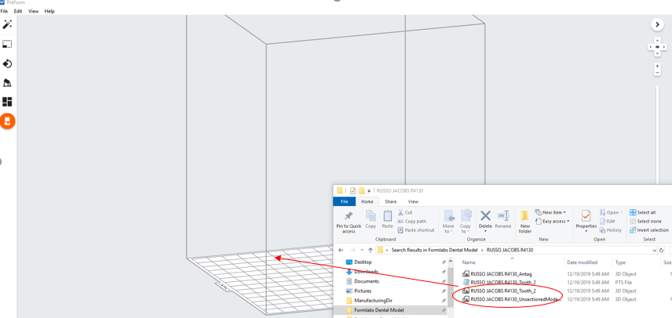

Step 4.  Click the support icon and change the density settings to the following:

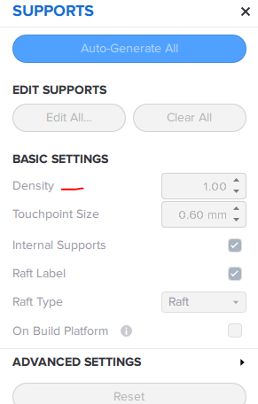

Solid = 1.2

Quad = 1.2 – 1.3

Full = 1.3 – 1.35

Change the touchpoint size settings to the following:

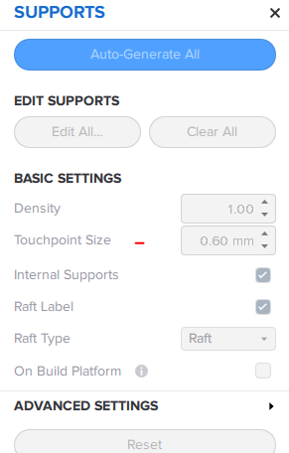

Solid = .75

Quad = .75 - .8

Full = .8 - .85

Step 5. Edit the supports if any are too close to margins. The marked support is too close to the margin and would need to be deleted / moved:

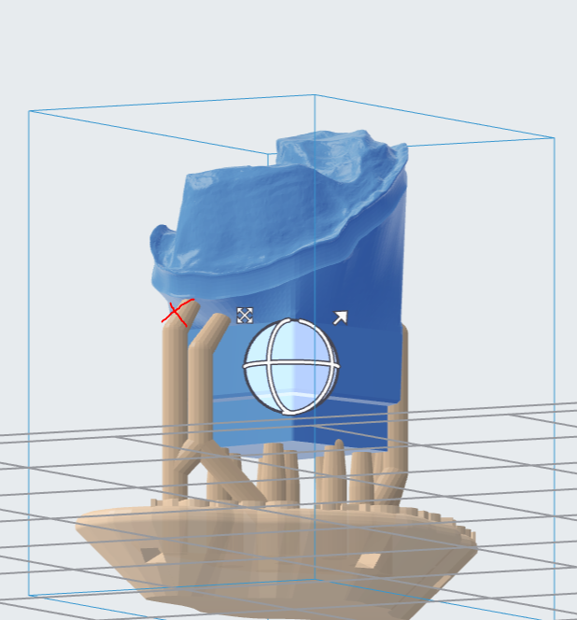

To remove, click edit support and left click on the point to be removed.

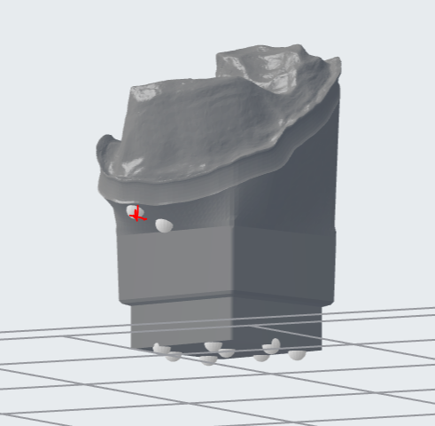

Click anywhere else to create a new support.

Check for printability.

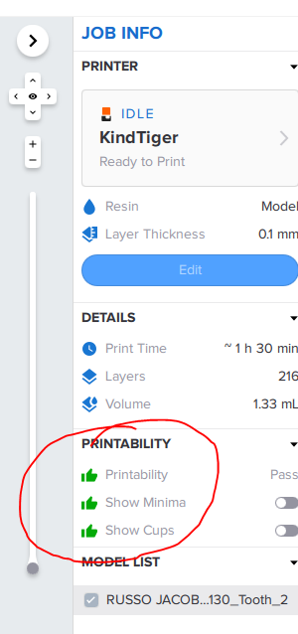

Step 6. Click on the layout icon  to choose layout all for automatic layout functions.

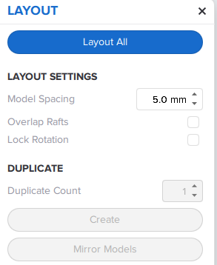

Step 7. Click file – save as to save the print job prior to sending it to the printer.

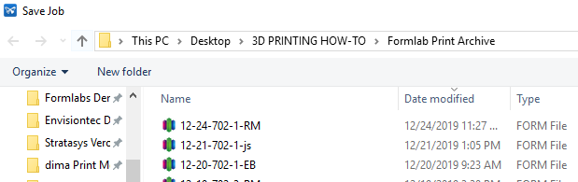

Then click the printer icon  and upload job to send the job to the printer.

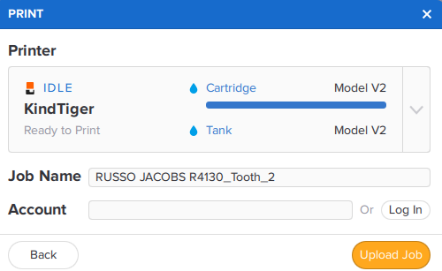

Step 8. On the printer, gently agitate the resin cartridge to help the resin flow. Press the print now button on screen and follow directions to start print job.

Step 9. Post process job by removing build platform upon completion of print job. Please use proper PPE per training.

Step 10. Remove print from build platform and place in first alcohol bath for 10 min. Brush and place in second bath for 10 min.

Step 11. Remove from bath, dry with compressed air, and let stand for 3 – 5 minutes prior to cure.

Step 12. Cure for 30 minutes, remove supports, clean up, and place in appropriate case for movement to next step.

Step 13. Complete all necessary maintenance prior to starting next job.

In conclusion, the steps to excellence are as follows:

* Keep everything CLEAN
* WORK SAFE ***and FOLLOW THE PROCEDURE***